How to apply a Virtual Background

Changing the Virtual Background on desktop

**Windows | macOS**

1. Sign in to the **Zoom desktop client**.
2. Click your profile picture, then click  **Settings**.  
   
3. Select**Backgrounds & Filters**.  
   **Note**: If you do not have the **Virtual Background** tab and you have enabled it on the web portal, sign out of the Zoom desktop client and sign in again.
4. Check **I have a green screen** if you have a physical green screen set up. You can then click on your video to select the correct color for the green screen.
5. Click on an image or video to select the desired virtual background.
6. (Optional) Add your own image by clicking and choosing if you want to upload an image or a video. 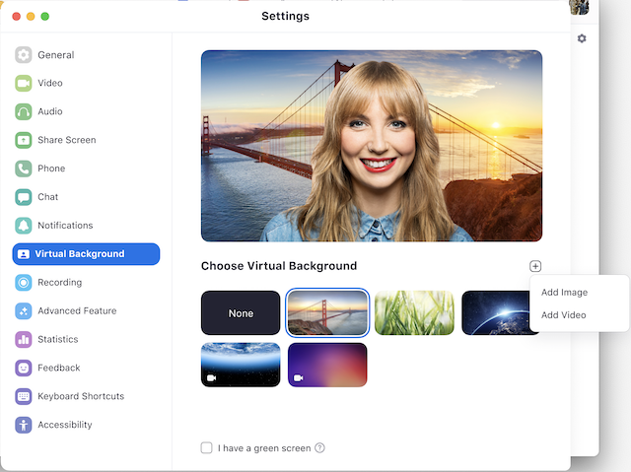  
   If prompted, click **Download** to download the package for virtual background without a green screen.  
   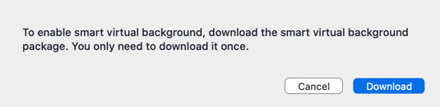

**Notes:**

* To disable Virtual Background, open the virtual background options again and choose the option **None**.
* Ensure that you are using a solid background color when **I have a green screen** is checked.
* After you select an option, that virtual background will be used for your future meetings.
* For more information about the **Blur** option, please refer to the **Blurred background article**.
* If your account admin set a default virtual background, they can also enabled it to reset back to the default if you changed your virtual background during a meeting.

**Web client**

By default, the web client provides users with a simplified virtual background experience, known as **Mask Background**. This uses less system resources, which makes it a viable option for most devices.

Devices meeting the **necessary system requirements** can also use the Virtual Background feature.

1. Join or start a meeting/webinar through the web client.
2. In the controls toolbar, click the ** Settings** button.
3. Click the **Background** tab.
4. Select the **Virtual Background** checkbox to enable.   
   If unchecked, **Mask Background** is used.
5. Click on an image to select the desired virtual background.
6. (Optional) Add your own image by clicking   and selecting the image you want to upload.

Changing the Virtual Background on mobile

**Android | iOS**

1. Sign in to the **Zoom mobile app**.
2. While in a Zoom meeting, tap **More** in the controls.  
   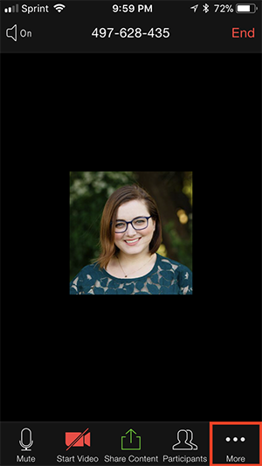
3. Tap **Background and Effects**.
4. Tap the background you would like to apply or tap **+** to upload a new image. The background will be automatically applied.  
   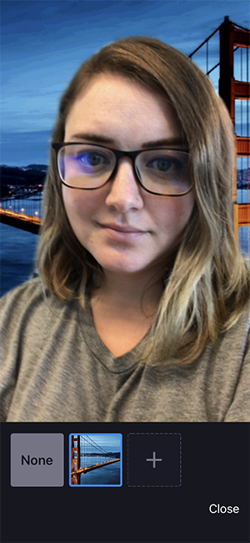
5. Tap **Close** after selecting the background to return to the meeting.

**Notes**:

* After you select an option, that virtual background will be used for your future meetings.
* For more information about the **Blur** option, please refer to the **Blurred background article**.
* To disable Virtual Background, open the virtual background options again and choose the option **None**.
* If your account admin set a default virtual background, they can also enabled it to reset back to the default if you changed your virtual background during a meeting.